ONLINE VEHICLE PARKING RESERVATION SYSTEM
Conclusion, Future Scope and References
Department of Computer Science and Engineering, TKR College of Engineering & Technology
Batch C3 (CSE-C) · Academic year [ACADEMIC YEAR]
Table 1: Project team
S.No. | Student name | Roll number
1 | Palle Yashaswini | 23K91A05H9
2 | Mohammed Muneeb Ahmed | 24K95A0518
3 | Kamasani Manisha | 24K95A0513
4 | Pothagani Nithyya Bhargava | 23K91A05J6

Project guide: V Pallavi
Chapter and section numbers quoted in the text (for example Chapter 8 or Section 6.2) refer to the full project report, 17.Final Document. Figures and tables in this document are numbered from 1.

1. CONCLUSION

1.1 Summary
ParkSure is a working Online Vehicle Parking Reservation System. Drivers search availability for a time window, reserve in advance, pay through Stripe in test mode or an offline demo checkout, and check in and out; administrators manage locations and read the overview and Strategy Insights. Behind it, an availability engine admits a request only if overlapping bookings plus a hold-back buffer stay below capacity, moves a driver to the nearest alternate when a lot is full on arrival, and prices every booking by a Trust Score. It is built from 22 routes over 5 tables and was exercised with 70 tests, a simulator and 24 captured screens.

1.2 Objectives against outcomes
Table 2: Objectives against outcomes
Objective | Outcome | Evidence
1 Registration, authentication and vehicle profile | Partly achieved | Registration, login, JWT, roles and Trust Score work and are tested; no vehicle profile exists
2 Real-time slot availability | Achieved as a forecast | Search returns bookable bays per window in 5.7 ms; no sensors, so not a live occupancy reading
3 Search, advance reservation and cancellation | Achieved | Reserve 19.6 ms; cancel refunds to credit; 36 API tests
4 Secure online payment and digital receipts | Partly achieved | Stripe test mode and demo checkout; payment status stored; no downloadable receipt; demo-confirm route is a weakness
5 Administrator dashboard | Achieved | Overview, locations, bookings, users, revenue, unable-to-park, declined and Strategy Insights
6 Evaluate success rate, allocation efficiency and response time | Achieved with a simulator | 30 runs per cell, five policies, utilisation, latency and probes; no real-user data

1.3 Key findings
1. The engine is correct against its own specification. 70 tests pass and the simulator agrees with the engine on 10,300 decisions (0 mismatches).
2. The platform is fast enough for its purpose. On this machine search takes 5.7 ms, reserve 19.6 ms, check-in 14.9 ms and check-out 14.6 ms; login takes 220 ms by design and eight threads sustained 131 search requests per second.
3. The shipped dynamic buffer is the most conservative policy. At 100 vehicles it refused 277 of 1000 requests, against 165 for the paper-literal rule, 158 for a static buffer of 3 and 30 for none. The paper's conclusion that a dynamic buffer is best was not reproduced for it.
4. Failures at the gate are rare in every policy (at most 1.4 per run in about 1,000 requests) because the alternate step absorbs them; the cost shows up as alternate moves and, at high overstay shares, alternate overflows.
5. The Trust lockout dominates refusals. With a quarter of drivers overstaying the lockout refused 136 requests per run against 22 refused by admission with no buffer; at half of drivers it refused 271. A driver who ends 30 percent of sessions late reaches a mean score of 1.8 and 80 percent are suspended at some point.
6. The team's own probes found real defects: an over-booking race, an unauthenticated payment confirmation, a default token secret and two slow list routes.
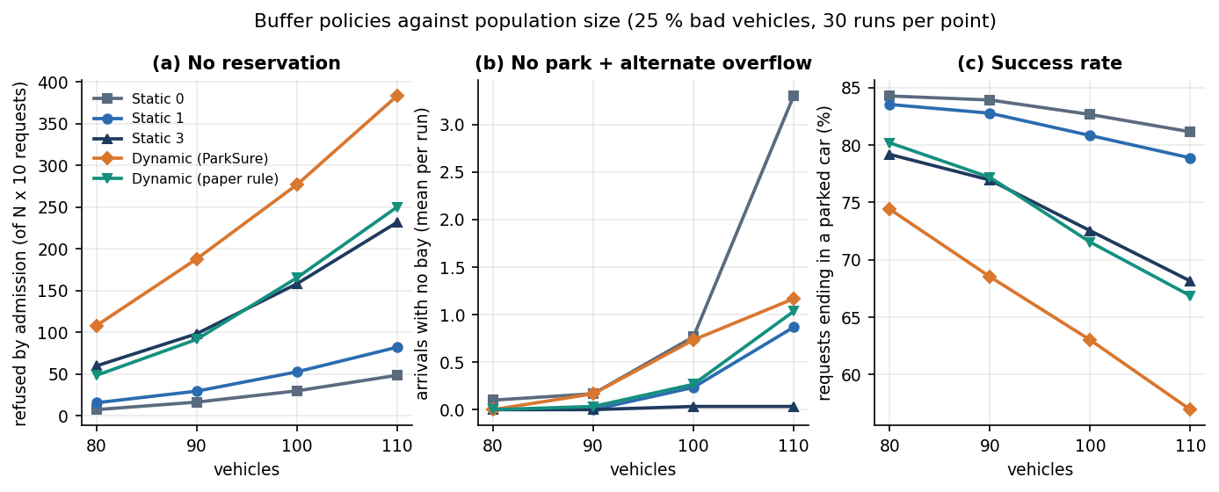
Figure 1: Refusals, gate failures and success rate of five buffer policies against population size (simulator, 30 runs per point).
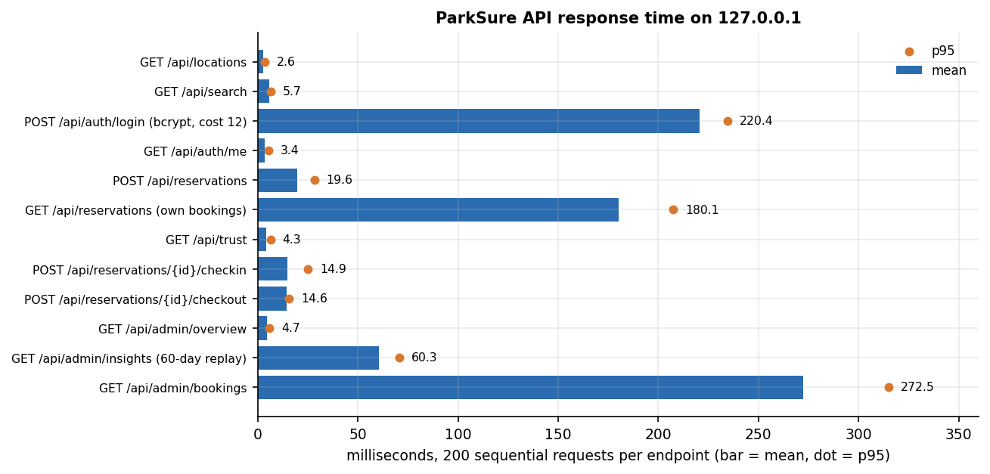
Figure 2: Mean and 95th percentile response time of the ParkSure API on 127.0.0.1.

1.4 Limitations
The evidence is simulated and seeded rather than field data, the simulator is not SUMO, no user study was run, and the defects listed in the limitations section remain open. The results demonstrate that the mechanism works and show how its policies trade refusals against failures; they do not predict the behaviour of a real car park.
The measurements behind the key findings are shown below: how the buffer policies compare in the simulator, and how the same history behaves under the four policies in the Strategy Insights replay. Both use data produced by the product itself, not field data, and neither is a replication of the simulation in the base paper.
Figure 3: Buffer policies against population size (25 % overstaying vehicles, 30 simulator runs per point).
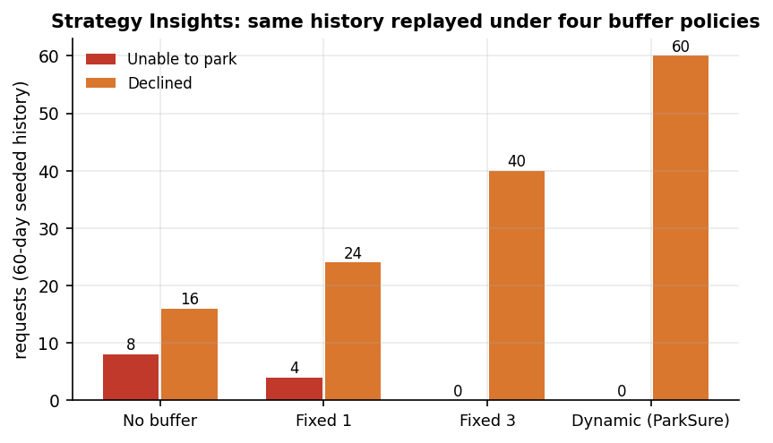
Figure 4: Strategy Insights: the seeded 60-day history replayed under four buffer policies (synthetic data).

2. FUTURE SCOPE

2.1 Close the defects found
• Make admission atomic. Take a lock or use a serialisable transaction around the overlap count and the insert, or store a per-location, per-slot-window counter with a unique constraint; repeat the 20-request race probe until no trial over-books.
• Remove the unauthenticated demo-confirm route when Stripe keys are present, and verify payment only through the signed webhook.
• Require a secret from the environment and refuse to start with the shipped default; add a rate limit and lockout to login.
• Validate times: reject windows that start in the past and allow check-in only inside a tolerance around the booked start.
• Replace the per-row queries with joined queries so the booking lists answer in tens of milliseconds.

2.2 Test the buffer rule on real data
• Run the paper's direction (grow on late departure) side by side with the shipped one on real booking histories, and choose by refusals and failures together.
• Repeat the experiment in SUMO with the original parameters of [2], [21] to compare against its figures directly.

2.3 Add features
• A vehicle profile (plate, type, colour) and a downloadable receipt with payment details, which complete batch objectives 1 and 4.
• Sensor and number-plate integration so that occupancy is read rather than assumed, with check-in at the gate.
• Dynamic pricing by demand and time of day, building on the multiplier table, in the spirit of [13].
• A mobile application and push notifications for expiry and overstay warnings.

2.4 Deploy and scale
• Move to PostgreSQL, run several worker processes behind a proxy and add a job queue for the buffer reset.
• Add monitoring of refusals, failures and latency per location so the buffer can be tuned with data.

3. REFERENCES
[1] M. Jemmali, L. K. B. Melhim, A. Ammar, T. R. Gadekallu and W. Boulila, "Smart parking for medical cities via passenger-aware allocation and fast grouping-permutation heuristics," IEEE Open Journal of the Computer Society, vol. 7, pp. 1106-1118, 2026, doi: 10.1109/OJCS.2026.3693801.
[2] G. Cabri, M. Montangero, F. Muzzini and R. Wang, "Reservation based smart parking management," arXiv:2605.17650 [cs.MA], May 2026.
[3] M. Aljohani, S. Olariu, A. Alali and S. Jain, "A survey of parking solutions for smart cities," IEEE Transactions on Intelligent Transportation Systems, vol. 23, no. 8, pp. 10012-10029, 2021.
[4] X. Xiao, Z. Peng, Y. Lin, Z. Jin, W. Shao, R. Chen, N. Cheng and G. Mao, "Parking prediction in smart cities: A survey," IEEE Transactions on Intelligent Transportation Systems, vol. 24, no. 10, pp. 10302-10326, 2023.
[5] S. R. Rizvi, S. Zehra, R. Mukkamala and S. Olariu, "ASAP: An agent-assisted smart auction-based parking system in Internet of Things," in Proc. 9th ACM Symp. on Design and Analysis of Intelligent Vehicular Networks and Applications, 2019, pp. 1-8.
[6] S. R. Rizvi, S. Zehra and S. Olariu, "MaPark: A multi-agent auction-based parking system in Internet of Things," IEEE Intelligent Transportation Systems Magazine, vol. 13, no. 4, pp. 104-115, 2020.
[7] N. Doulamis, E. Protopapadakis and L. Lambrinos, "Improving service quality for parking lot users using intelligent parking reservation policies," in Proc. 27th Int. Conf. on Advanced Information Networking and Applications Workshops, IEEE, 2013, pp. 1392-1397.
[8] E. Kokolaki, M. Karaliopoulos and I. Stavrakakis, "Trading public parking space," in Proc. IEEE Int. Symp. on a World of Wireless, Mobile and Multimedia Networks, 2014, pp. 1-6.
[9] G. Yan, W. Yang, D. B. Rawat and S. Olariu, "SmartParking: A secure and intelligent parking system," IEEE Intelligent Transportation Systems Magazine, vol. 3, no. 1, pp. 18-30, 2011.
[10] R. R. Safitri, A. Pratiarso and A. Zainudin, "Mobile-based smart parking reservation system with rate display occupancy using heuristic algorithm and haversine formula," in Proc. 2020 Int. Electronics Symp. (IES), IEEE, 2020, pp. 332-339.
[11] A. Somani, S. Periwal, K. Patel and P. Gaikwad, "Cross platform smart reservation based parking system," in Proc. 2018 Int. Conf. on Smart City and Emerging Technology (ICSCET), IEEE, 2018, pp. 1-5.
[12] N. Mejri, M. Ayari, R. Langar and L. Saidane, "Reservation-based multi-objective smart parking approach for smart cities," in Proc. 2016 IEEE Int. Smart Cities Conf. (ISC2), 2016, pp. 1-6.
[13] A. O. Kotb, Y.-C. Shen, X. Zhu and Y. Huang, "iParker - a new smart car-parking system based on dynamic resource allocation and pricing," IEEE Transactions on Intelligent Transportation Systems, vol. 17, no. 9, pp. 2637-2647, 2016.
[14] F. Muzzini, N. Capodieci and M. Montangero, "Improving urban viability through smart parking," International Journal of Parallel, Emergent and Distributed Systems, vol. 38, no. 6, pp. 522-540, 2023.
[15] R. Chen, G. Gao, L.-J. Kang and L.-Y. Zhang, "Efficiency and equity analysis on parking reservation," Transportation Research Part E: Logistics and Transportation Review, vol. 187, art. no. 103606, 2024.
[16] M. Jemmali, L. K. B. Melhim, M. T. Alharbi, A. Bajahzar and M. N. Omri, "Smart-parking management algorithms in smart city," Scientific Reports, vol. 12, no. 1, pp. 1-15, 2022.
[17] Y. Geng and C. G. Cassandras, "A new 'smart parking' system infrastructure and implementation," Procedia - Social and Behavioral Sciences, vol. 54, pp. 1278-1287, 2012.
[18] Z. Hu, Y. Cao, J. Huang, L. Wu, L. Xu and R. Zhang, "CRPark: A smart parking system with competition and reservation services," IEEE Transactions on Vehicular Technology, vol. 74, no. 8, pp. 12981-12996, Aug. 2025.
[19] A. Fahim, M. Hasan and M. A. Chowdhury, "Smart parking systems: Comprehensive review based on various aspects," Heliyon, vol. 7, no. 5, art. no. e07050, 2021.
[20] A. O. Elfaki, W. Messoudi, A. Bushnag, S. Abuzneid and T. Alhmiedat, "A smart real-time parking control and monitoring system," Sensors, vol. 23, no. 24, art. no. 9741, 2023.
[21] P. A. Lopez, M. Behrisch, L. Bieker-Walz, J. Erdmann, Y.-P. Flotterod, R. Hilbrich, L. Lucken, J. Rummel, P. Wagner and E. Wiessner, "Microscopic traffic simulation using SUMO," in Proc. 21st IEEE Int. Conf. on Intelligent Transportation Systems (ITSC), 2018, pp. 2575-2582.
[22] J. Kleinberg and E. Tardos, Algorithm Design. Boston, MA, USA: Addison-Wesley, 2006.
[23] R. W. Sinnott, "Virtues of the haversine," Sky and Telescope, vol. 68, no. 2, p. 159, 1984.
[24] R. T. Fielding, "Architectural styles and the design of network-based software architectures," Ph.D. dissertation, Dept. Inf. Comput. Sci., Univ. California, Irvine, CA, USA, 2000.
[25] M. Jones, J. Bradley and N. Sakimura, "JSON Web Token (JWT)," IETF RFC 7519, May 2015.
[26] N. Provos and D. Mazieres, "A future-adaptable password scheme," in Proc. USENIX Annual Technical Conf., FREENIX Track, 1999, pp. 81-91.
[27] M. Bayer, "SQLAlchemy," in The Architecture of Open Source Applications, Volume II, A. Brown and G. Wilson, Eds., 2012.
[28] S. Ramirez, "FastAPI documentation," [Online]. Available: https://fastapi.tiangolo.com (accessed Oct. 2026).
[29] Stripe, Inc., "Stripe Checkout and webhooks documentation," [Online]. Available: https://docs.stripe.com (accessed Oct. 2026).
[30] Meta Platforms, Inc., "React documentation," [Online]. Available: https://react.dev (accessed Oct. 2026).
[31] "Design and implementation of a web-based smart vehicle parking reservation and management system with real-time slot allocation," American Journal of AI Cyber Computing Management, 2026 (title and source as listed in the batch literature survey; not located online and not quoted).
[32] "Digital parking slot reservation system for vehicles," International Journal of Engineering Science and Advanced Technology, 2026 (title and source as listed in the batch literature survey; not located online and not quoted).
[33] "Parking slot prediction and face recognition based parked vehicle theft prevention in smart parking system," International Research Journal of Modernization in Engineering Technology and Science, 2024 (title and source as listed in the batch literature survey; not located online and not quoted).
[34] "Smart vehicle parking reservation system using web and mobile technologies," Research Digest on Engineering Management and Social Innovations, 2026 (title and source as listed in the batch literature survey; not located online and not quoted).

